Original FMCPT t-shirt

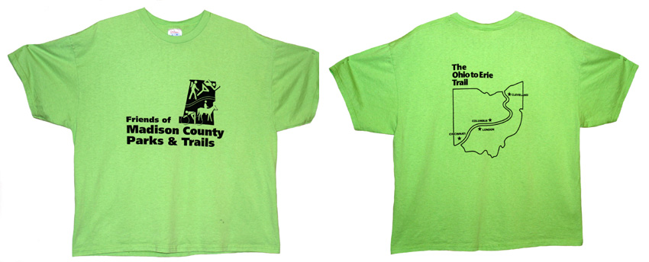

Return printable form with check made payable to: FMCPT

Mail to: FMCPT
P.O. Box 308

London, Ohio 43140

The original FMCPT t-shirt ($15) comes in green with the FMCPT logo on the front and an Ohio to Erie Trail map on the back. Please indicate the quantity for each size:

Youth: ____ 2-4 _____ 6-8 _____ 10-12 ____ 14-16 _____ 18-20

Adult: ____ S _____ M _____ L _____ XL _____ 2XL _____ 3XL

Name __________________________________________________________________

Street Address ___________________________________________________________

City _________________________________ State ___________ Zip ______________

Phone number ___________________________________________________________

Email address ____________________________________________________________

This order can be picked up without a shipping fee at the next FMCPT meeting, or it can be shipped directly to your address above for a $5 shipping fee. Please allow up to two weeks for delivery.

Total quantity _____ X $15 = ____________ + $5 shipping (if desired)

Total amount enclosed: ________________________

Friends of Madison County Parks and Trails is a 501(c)3 nonprofit organization.

